Requirements Elicitation

A mock interview was held between me and a classmate where I played the role of a software engineer and they played the role of a client whom I would develop a banking system for. From the interview held I was able to elicit the following requirements. The following organisational names are fictional used only for the purpose of education and generic development.

Developer- Motsholathebe Maatla Bowelo
Client on Behalf of BroadBankBotswana- Pako Daniel

NON-Functional Requirements

The non-functional requirements are categorised into 4 sections namely: Performance, Reliability, Usability, Scalability

1. Performance
- Recorded transactions should quickly be processed
- The system should be able to support multiple users with no lag

2. Reliability
- The system must be up and running at all times
- Transactions must be well detailed meaning they must either be complete or not registered entirely

3. Usability
- The banking system must have a simple user interface
- The system must have clear error messages and validation prompts
- The system must have descriptive documentation

4. Scalability
- Should allow users to have multiple accounts
- Able to support sudden increase of customers without performance drops

Functional Requirements

The functional requirements are categorised into 4 sections namely: Registration, Account Management, Transactions and Authentication & Security

1. Register Customers
- Be able to register customers with details names, address, employer details etc
- Be able to update the customer details
- View Customer Information

2. Account Management
- Allow customer to open multiple accounts namely savings, investment and cheque - View account details

3. Transactions
- Deposit funds into any account
- Withdraw funds from any account
- Automatically calculate and add interest to respective accounts
- View transaction history

4. Authentication & security
- Provide a safe login space for customers to use
- Ensure only customers can use the system
- Allow staff use system for management purposes

CLASS DIAGRAM

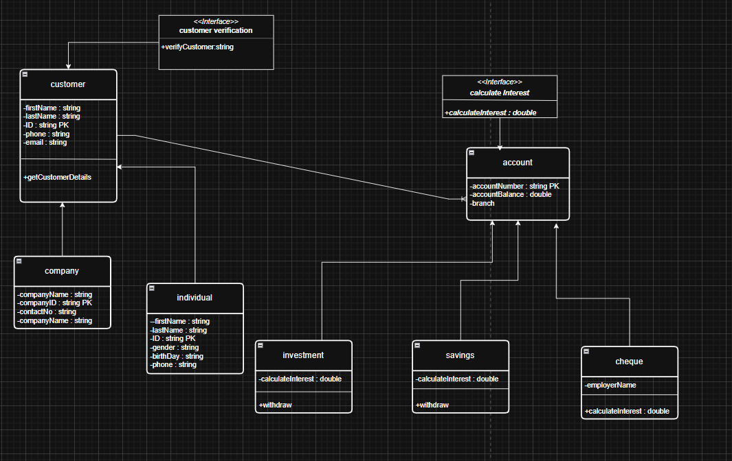

DEPOSIT SEQUENCE DIAGRAM

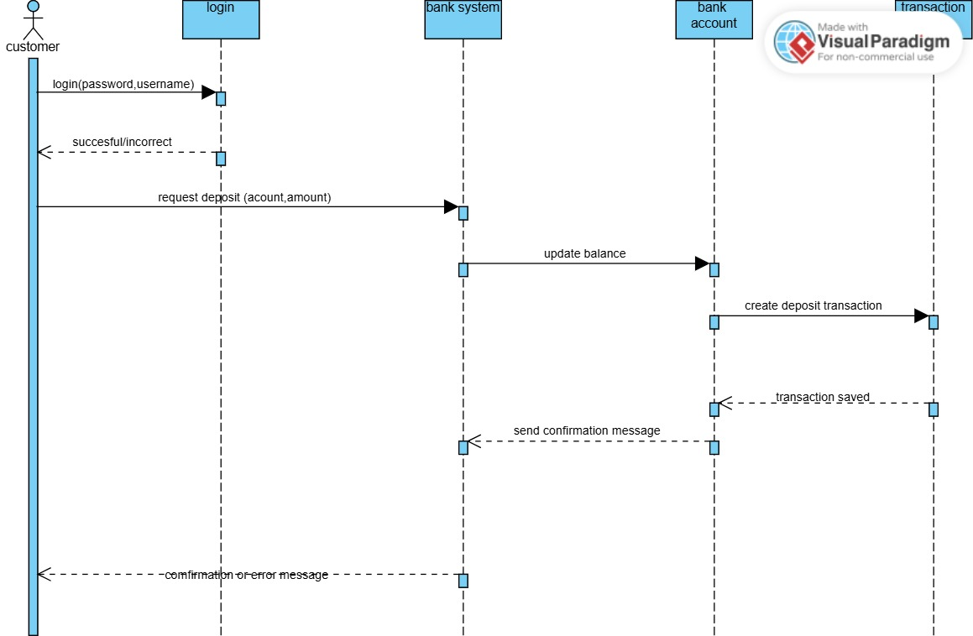

WITHDRAWAL SEQUENCE DIAGRAM
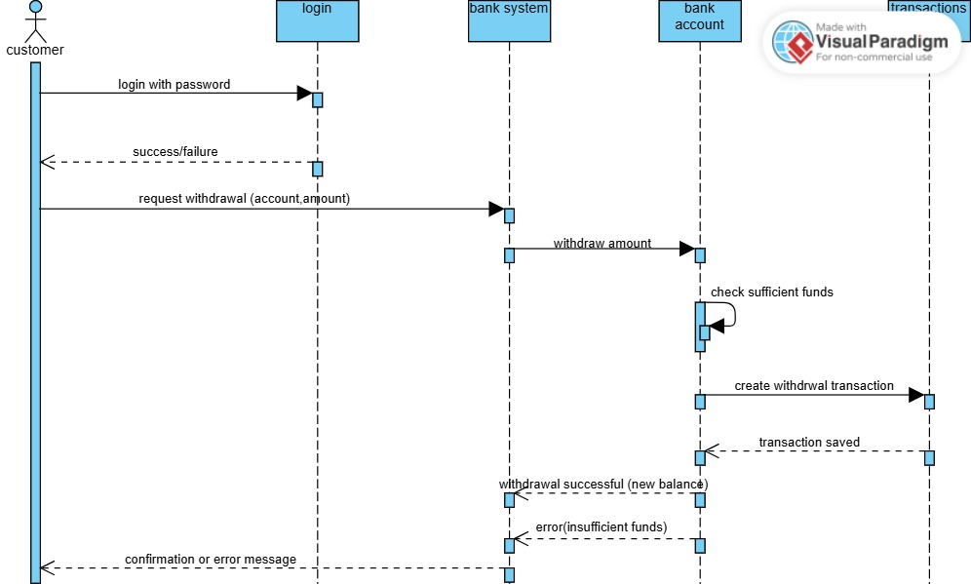

STATE DIAGRAM
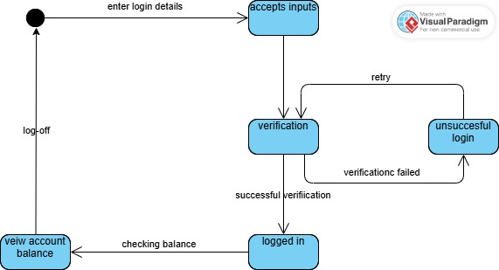

USE CASE DIAGRAM
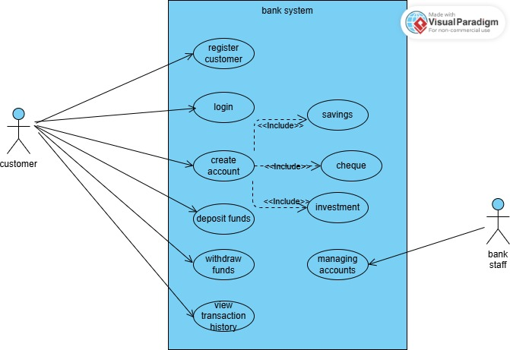

Mock Interview Record

Interviewer: What are the features or abilities you would like the system to have?

Client: We want a system that is secure for users, that will be able to register and accounts, and perform basic transactions such as deposit and withdrawal.

Interviewer:Are there restrictions on different accounts such as varying interest rates, etc?

Client: Yes savings accounts do not have withdrawals, investment accounts require an opening balance of P500.

Interviewer: Speaking of investment accounts ,what interest rates do they have?

Client: Savings accounts have 0.05% monthly while investment accounts earn 5% monthly.

Interviewer: Any security concerns?

Client: Yes the system must log in to the system safely with no vulnerability threats.

Interviewer: Who will use the system?

Client: Bank staff along with the customer to manage accounts and verify details.

Interviewer: Thank you for your time. Those are all the questions I have for you.

Client: Okay how long will development take?

Interviewer: I can’t give estimates at this time but we’ll keep in touch.

Client: Thank you.

